How to active battery again
If you find that when you plug power adapter to Sanbot all the time, the power status always stuck at the same percentage. When we unplug the battery and measure the 8PIN socket, all of the 4 group voltage is 0 V, it maybe because of battery totally run out of power. If we normally just plug the power adapter to robot, the battery can’t be active. If you have this kind of issue, please read the guide below to active batter gain.
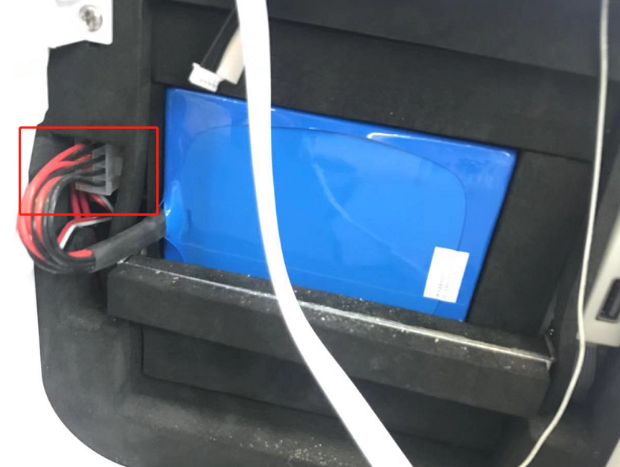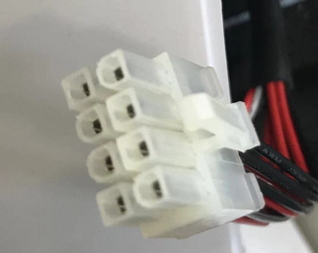

Step 1: Power off robot.
Step 2: Plug power adapter to robot DC interface to charge the battery.
Step 3: 15 minutes later, unplug of robot power adapter.
Step 4: 10-15 seconds later, plug the power adapter back to robot to start to charge robot again.
Step 5: 15 minutes later, unplug of robot power adapter.
Step6:10-15 seconds later, plug the power adapter back to robot to start to charge robot again.
Step7: 1 hour later, unplug of the robot power adapter.
Step8:Power on robot and check

